CITRIC ACID
Citric acid is the most important organic acid and is extensively used in food and pharmaceutical industries.It is produced mainly by submerged fermentation using Aspergillus niger or Candida sp. from different sources of carbohydrates, such as molasses and starch based media. However, other fermentation techniques, e.g. solid state fermentation and surface fermentation, and alternative sources of carbon such as agro-industrial residues are also used.
Introduction
Citric acid most versatile and widely used organic acid in the field of food (60%) and pharmaceuticals (10%).
Applications of citric acid
Citric acid is mainly used in food industry because of its pleasant acid taste and its high solubility in water. It is worldwide accepted as "GRAS" (generally recognized as safe), approved by the Joint FAO/WHO Expert Committee on Food Additives.
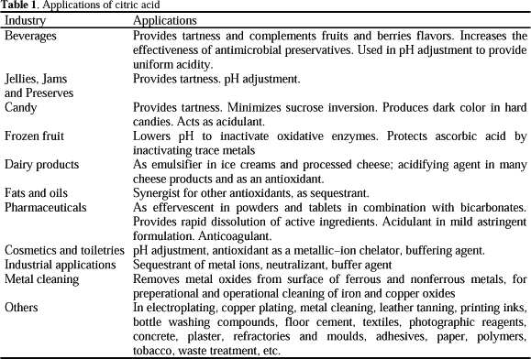

MICRO-ORGANISMS USED FOR CITRIC ACIC PRODUCTION
A large number of micro-organisms including bacteria, fungi and yeasts have been employed to produce citric acid. A. niger and certain yeasts such as Saccharomycopsis sp. are employed for commercial production. The main advantages of using this micro-organism are: (a) its ease of handling, (b) its ability to ferment a variety of cheap raw materials, and (c) high yields.

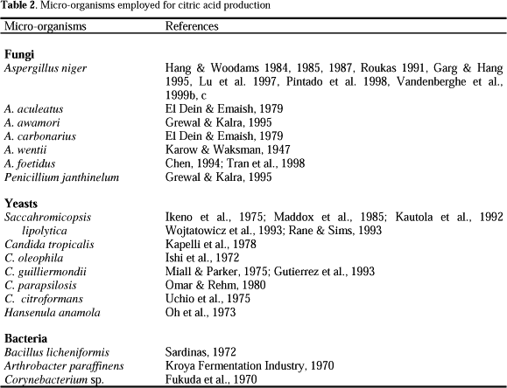

FACTORS AFFECTING CITRIC ACID FERMENTATION
The accumulation of citric acid is strongly influenced by the composition of the medium, especially in submerged fermentation processes. Factors that mainly affects the citric fermentation are the type and concentration of carbon source, nitrogen and phosphate limitation, pH, aeration, oligoelements concentration, and morphology of the producing microorganism. Certain nutrients have to be in excess (such as sugars, protons or oxygen), other at limiting levels (such as nitrogen and phosphate) and others below well-established threshold values (such as trace metals, particularly manganese).
Carbon source: Citric acid accumulation is strongly affected by the nature of the carbon source. The presence of easily metabolized carbohydrates is essential for good production of citric acid. sucrose is the most favourable carbon source followed by glucose, fructose and galactose.
Nitrogen source: Citric acid production is directly influenced by the nitrogen source. Physiologically, ammonium salts are preferred, e.g. urea, ammonium sulfate, ammonium chloride, peptone, malt extract, etc. Nitrogen consumption leads to pH decrease, which is very important in citric acid fermentation. The concentration of nitrogen source required for citric acid fermentation is 0.1 to 0.4 N /liter. A high nitrogen concentration increases fungal growth and the consumption of sugars, but decreases the amount of citric acid produced.
Phosphorous source: Presence of phosphate in the medium has a great effect on the yield of citric acid. Potassium dihydrogen phosphate is the most suitable phosphorous source. phosphorous at concentration of 0.5 to 5.0 g/L is required by the fungus in a chemically defined medium for maximum production of citric acid. Phosphate is essential for the growth and metabolism of A. niger.
Trace elements: Trace element nutrition is the main factor influencing the yield of citric acid. A number of divalent metals such as zinc, manganese, iron, copper and magnesium affect citric acid production by A. niger.

Process parameters
pH: The pH of a culture changes in response to microbial metabolic activities. The most obvious reason is the secretion of organic acids such as citric, acetic or lactic acids, which cause the pH to decrease. Changes in pH kinetics depend highly also on the micro-organism. With Aspergillus sp., Penicillium sp. and Rhizopus sp., pH drop very quickly until less than 3.0. For other groups of fungi such as Trichoderma, Sporotrichum, Pleurotus sp., pH is more stable (between 4 and 5).
Generally, a pH below 2.0 is required for optimum production of citric acid. A low initial pH has the advantage of checking contamination and inhibiting oxalic acid formation. A pH of 2.2 is optimum for the growth of the mould as well as for the production of citric acid whereas, a higher pH i.e. 5.4 and 6.0-6.5 has been found optimum for citric acid production in molasses medium .
Aeration: Aeration has a determinant effect on citric acid fermentation . Increased aeration rates led to enhanced yields and reduced fermentation time . It is important to maintain the oxygen concentration above 25% saturation.
Liquid fermentation
Submerged fermentation: The submerged fermentation (SmF) process is the commonly employed technique for citric acid production. About 80% of world production is obtained by SmF. Several advantages such as higher yields and productivity and lower labour cost.Two types of fermenters, conventional stirred fermenters and tower fermenters are employed, although the latter is preferred due to the advantages it offers on price, size and operation.
In SmF, different kinds of media are employed such as sugar and starch based media. Molasses and other raw materials demand pre-treatment, addition of nutrients and sterilization. Inoculation is performed either by adding a suspension of spores, or of pre-cultivated mycelia. When spores are used, a surfactant is added in order to disperse them in the medium. For pre-cultivated mycelia, an inoculum size of 10% of fresh medium is generally required. Normally, submerged fermentation is concluded in 5 to 10 days depending on the process conditions. It can be carried out in batch, continuous or fed batch systems, although the batch mode more frequently used.
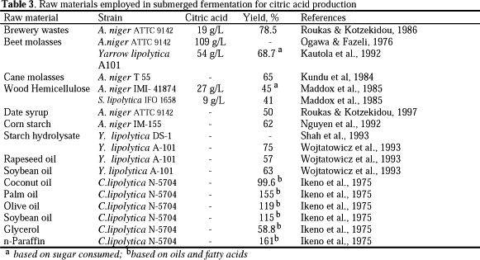

Surface fermentation: surface method required less effort in operation, installation and energy cost. In the classical process for citric acid manu-facture, the culture solution is held in shallow trays (capacity of 50-100 L) and the fungus develops as a mycelial mat on the surface of the medium. The trays are made of high purity aluminium or special grade steel and are mounted one over another in stable racks. The fermentation chambers are provided with an effective air circulation in order to control temperature and humidity. Fermentation chambers are always in aseptic conditions, which might be conserved principally during the first two days when spores germinate.
Solid-state fermentation
Solid-state fermentation (SSF) ,termed as an alternative method to produce citric acid from agro-industrial residues Citric acid production by SSF (the Koji process) was first developed in Japan and is as the simplest method for its production. SSF can be carried out using several raw materials. Generally, the substrate is moistened to about 70% moisture depending on the substrate absorption capacity. The initial pH is normally adjusted to 4.5-6.0 and the temperature of incubation vary from 28 to 30°C. The most common organism is A. niger. One of the important advantages of SSF process is that the presence of trace elements may not affect citric acid production so harmfully as it does in SmF. Consequently, substrate pre-treatment is not required. Different types of fermenters such as conical flasks, glass incubators and trays, etc. have been used for citric acid fermentation in SSF.
Downstream processing
Electrodialysis
This process enables separation of salts from a solution and their simultaneous conversion into the corresponding acids and bases using electrical potential and mono- or bipolar membrane. Before the fermentation solution comes to the electrodialysis some pretreatment steps are normally necessary: filtration of the broth, removal of ionogenic substances (especially Ca⁺⁺ and Mg⁺⁺ ions) and neutralization by means of sodium hydroxide. In the subsequent electrodialytic step the sodium citrate solution is converted into base and citric acid, which is simultaneously concentrated and for the most part purified. The produced NaOH may be reused for the neutralization.

